Emergency Religious Leaders’ Delegation to Honduras  January 24-30, 2018 | “Your people will be my people.” Ruth 1:16

Emergency Religious Leaders’ Delegation to Honduras
January 24-30, 2018

Executive Summary
“Your people will be my people.” Ruth 1:16

DELEGATION MANDATE
On January 24th, 2018 fifty faith and civic leaders from the United States, Canada, Colombia, and Argentina embarked on a six-day Emergency Religious Delegation to Honduras in the aftermath of a contested presidential election and reports of state-sponsored human rights violations against the Honduran people. Eight religious denominations were represented by the 40+ faith groups and human rights organizations that sent delegates from 13 states in the U.S. The group traveled to Honduras in response to an invitation from Jesuit Father Ismael “Melo” Moreno, director of Radio Progreso and ERIC (Equipo de Reflexión, Investigación y Comunicación), and other faith groups in Honduras who accompany impoverished and marginalized people.
We were invited to:
- accompany and lend protection to Fr. Melo and the Honduran people as they exercise their rights to freedom of speech and assembly;
- observe human rights violations perpetrated against peaceful protests of the recent reelection of president Juan Orlando Hernandez;
- take the testimony of human rights defenders, activists and victims of the state-sponsored terrorism;
- meet with US Embassy representatives regarding US support for the regime; and
- report back to our home communities, public officials and global community.
OBSERVATIONS
Our delegation primarily spent time in San Pedro Sula and Progreso in the north of Honduras, and also traveled to the capital of Tegucigalpa. We met with the staffs of the Jesuit-sponsored Radio Progreso and ERIC. Radio Progreso is one of the few independent media stations in Honduras. ERIC is a leadership development program that promotes civic participation and community development. They have trained more than 900 young people under the age of 30, including indigenous, campesinos, religious and lay men and women around the themes of human rights, democracy, gender and ecological justice, and have sponsored a legal team to represent human rights defenders.
In addition, we met with Catholic congregations of men and women religious. We accompanied them to religious gatherings in support of a just resolution to the current crisis in the country. We met with survivors and relatives of victims who had been shot and killed by the National Police and Military using live ammunition to break up peaceful protests. We took testimonies of family members whose loved ones were arrested and tortured by the Honduran Security Forces. We wept and prayed with these victims, including a young father of two, who was left paralyzed and brain-damaged after being shot while walking home from work near a protest.
Our delegation witnessed the use of tear gas against peaceful demonstrators first-hand. We were told of the military and police throwing tear gas canisters into homes, forcing families to flee. Peaceful protesters carried towels dipped in vinegar to offset the burning of their eyes and skin from exposure to the tear gas and pepper water sprayed on peaceful demonstrators as well as bystanders from military grade water cannons. We intervened to stop the arrest of the wife and children of an opposition leader who had received anonymous death threats. Fr. Melo and his team have also suffered recent and repeated death threats, as have other human rights defenders around the country. Many ordinary Honduran citizens shared stories of their fear and vulnerability in the context of shrinking space for free expression. As one woman expressed to our delegation following a public “Stations of the Cross” faith witness for justice, “We fear that after the (January 27th) inauguration, they will come and hunt us all down.”
The election of President Juan Orlando Hernandez was marred by significant irregularities, a conclusion corroborated by the Organization of American States (OAS) and the European Union (EU). The Hondurans with whom we met consistently reported their lack of confidence in the election and described the events surrounding it as a serious blow to Honduran democracy. The flawed process and the United States’ rush to endorse it destroyed any remaining trust in the integrity of the current political process.
The level of frustration was palpable. Many reported having been disillusioned by the 2009 coup d’état, and the subsequent removal of checks and balances, the stacking of the courts and governmental agencies by operatives loyal to economic and political elites rather than the Honduran constitution, and an epidemic of corruption as evidenced by the documented embezzlement of millions of dollars from the Public Health Ministry. The frustration and disillusionment were compounded by deepening inequality, threats of violence and assassination against human rights defenders and community leaders with near total impunity for the perpetrators, and the giveaways of nearly one-third of the country’s land to mining and extractive industries.
The January 27, 2018 inauguration of the fraudulently-elected president, Juan Orlando Hernandez, was the culmination of this ongoing, systematic betrayal of the democratic process.
FINDINGS
- The reelection of President Juan Orlando Hernandez is both unconstitutional and fraudulent. According to the Honduran constitution, no president can be reelected for consecutive terms. This constitutional law was overturned in 2015 without the consultation and consent of the Honduran people, and only after President Hernandez replaced four out of five Supreme Court justices. Furthermore, while the US has officially recognized the reelected regime, the OAS concluded that the election was “characterized by irregularities and deficiencies” and had called for a new general election. Civil society groups, as well as the Alianza Party, whose candidate challenged the National Party’s candidate, Hernandez, in the November 2017 election, have denounced the JOH government as “dictatorial.”

- Peaceful protests have been met with state-sponsored violence, repression and impunity.
- The constitutional right to peaceful assembly has been violated. Since the November 26, 2017, elections, Honduran security forces have killed at least 37 Honduran activists, protesters and bystanders with total impunity. Many more have been disappeared, imprisoned, and beaten.
- The constitutional right to a free press has also been undermined. Fr. Melo and other members of ERIC/Radio Progreso, have received anonymous death threats and faced police intimidation (including at the San Pedro Sula airport on their way to meet our delegation), and the radio station’s tower was sabotaged in December 2017.
- Basic human rights have been violated. In addition to hearing victims’ testimonies, members of our delegation witnessed the disproportionate presence of national police, military police, and military at protest sites, as well as their excessive use of teargas (in once instance firing over 100 canisters) and beating of protesters.

- The militarization of Honduran society, combined with impunity at every level of government, is a primary driver of inequality, human rights violations and migration.
Military and police spending has increased significantly since President Hernandez first took office in 2013, while social services like health and education have been systematically ignored. Increased militarization is inextricably linked to the structural violence of rampant poverty and social inequality in Honduras. Militarization only exacerbates unchecked violence and increasing poverty, both crucial drivers of migration of Hondurans to the United States.
The prevailing economic model in Honduras is based on export-focused African palm production, extractive industries like mining, and tourism that displaces indigenous and afro-descendant communities—all of which benefit a small, entrenched elite at the expense of the vast majority of Hondurans and that despoils the country’s rich natural resources. We heard a clear call from the Hondurans we met for land reform to benefit small farmers, greater investment in small businesses, and a respect for the territorial rights, lands and resources of indigenous and afro-descendant peoples currently subject to exploitation by mining and extractive industries. Such measures would greatly mitigate the out-migration of Hondurans to other countries, including the United States.
The current US immigration policy characterized by cancellation of Deferred Action for Children Arrivals (DACA) and Temporary Protective Status (TPS) for Hondurans and other Central Americans, the attack on sanctuary cities, the criminalization of migration, aggressive immigration raids, and the proposed border wall do not address the political-economic structures in Honduras that drive immigration. While the US Embassy defends its role in helping support Honduras’ “historically weak institutions” and justifies the role of the military in police functions until several thousand new police can be trained, recent history in Central America and current evidence in Honduras shows that such militarization only exacerbates and further destabilizes civil society through the corruption of political, social, judicial and security institutions.

- US support for, and security assistance to, the current Honduran government plays a fundamental role in abetting human rights violations in Honduras.
Two days after the controversial elections of November 26, 2017, the U.S. State Department certified Honduras to receive aid, including for their military and security forces, concluding that the country had progressed on issues of human rights and corruption. This certification, as well as its timing, sent a terrible signal of U.S. support for a regime engaged in repressing peaceful protest, and it misrepresented the reality of the rampant corruption and human rights violations conducted with total impunity in Honduras.
In mid-January, the Honduran Congress passed a bill that cripples the work of the Mission to Support the Fight against Corruption and Impunity in Honduras (MACCIH), an OAS body. In effect, the new law immediately stops investigations of corruption among current and former politicians, benefiting the president of the Legislative Assembly and nearly 30 others like him who knew they were under MACCIH investigation. Continued aid to Honduran security forces also undermines a path towards peace and accountability, as the weapons, armor, and tear gas manufactured in and exported from the US to Honduras will continue to be used against the Honduran people.
As all of the above makes plain, the US failure to denounce the presidential election as unconstitutional and fraudulent undermines peace and democracy in Honduras.
RECOMMENDATIONS AND CALLS TO ACTION
The International Emergency Delegation calls upon the Honduran government to:
- Stop the Repression
- Free protesters who have been jailed for participating in peaceful demonstrations.
- Cease repressing peaceful public protest.
- Cease the use of live ammunition.
- Cease the use of tear gas against protesters and against civilians in their homes.
- Stop the illegal search, seizure and prosecution of peaceful protesters.
- Stop the misuse of the justice system to convict and sentence peaceful protesters to long jail terms.
- Stop the militarization of Honduran civil society and remove the military and the military police from the streets.
- Ensure investigations and judicial accountability for those responsible for the assassinations of protestors from November 27, 2017 to the present.
- End the violence, character assassination and death threats directed against Rev. Ismael “Melo” Moreno and the staff of Radio Progreso/ERIC, as well as other human rights defenders and leaders of social movements.
The International Emergency Delegation calls upon the U.S. government and other governments to:
- End support for the current central government of Honduras and the illegitimate presidency of Juan Orlando Hernandez.
- Support the call for national dialogue to address the fraudulent election and current crisis--with an international mediator.
- End military and security aid to Honduras as per HR 1299, the Berta Caceres Act.
- End the militarization underway in the region.
- Stop deportation of Hondurans and other Central Americans, and support immigrant rights.
We call on all people of faith and good will to deepen efforts to build solidarity and sister relationships with the people of Honduras. Get educated, participate in delegations, and lend support for the social movements and human rights defenders at risk.

REFLECTIONS FROM THE INDIVIDUALS WHO ADDRESSED
US EMBASSY OFFICIALS ON BEHALF OF THE DELEGATION
- Fr. Jean Denis Saint-Félix, SJ, Secretary of the Office of Justice and Ecology at the Jesuit Conference of Canada and the United States - Washington, D.C. I came to support the Honduran people in this difficult time and to get first-hand information - to see and to hear. I also came because Padre Melo’s life has been threatened, as have the lives of his staff at Radio Progreso. We are very concerned for their lives. We recall the six Jesuits and two workers who were killed in El Salvador and know that this can happen again. I want to reaffirm the work that Padre Melo is doing and that Jesuits support this work. We also seek to protect the lives of all Honduran people.
**Presented “Circle of Terror” flyer to embassy staff
- Katherine Mulcahy, Dominican Sisters, Springfield, IL, USA I want to tell you the stories of some of the victims of police and military violence who met with us. Jose Luis was trying to leave a protest when he was shot in the face. He lost an eye. Maria Rios’s husband was walking home from work in an area near where a protest was happening when he was shot, near his home. He is now paralyzed and brain damaged. When his son ran out of the house to help him, he was arrested, and bathed in pepper spray. The wife of David recounted how her husband was shot and taken to a hospital. He was judged to be in good condition when he was visited in his room by two military men. They also accompanied him to the operating room where he died. His wife has filed denunciations with the police and says she is now persecuted and followed. The common theme we witnessed among these and other stories is that filing police reports or seeking protection of the state consistently leads to negative, often violent, repercussions. We are here to amplify these voices and those of other victims.
- Reverend Kathleen McTigue, Director, Unitarian Universalist College of Social Justice, Boston, MA, USA - We have been witnessing street protests and road occupations. In one case, a former legislator, Bartolo Fuentes, who has spoken against the government, was driving us home when he got a call that four uniformed policemen were invading his house. We drove to his house immediately. The police had pointed guns at the heads of his mother-in-law and son; his brother-in-law had been dragged from the house and the uniformed police kicked and beat him. This is state sponsored terrorism, which, as I understand, our laws do not allow us to support. Bartolo’s picture is at the center of the flyer we gave you that shows that he and his family have been targeted. Bartolo is also supposed to have protective measures to guarantee his safety.
- Darrin Mortenson, Migration Fellow, Maryknoll Office for Global Concerns, Washington, D.C., USA - I was in Pajuiles, Atlantida department, where there is a small encampment of people next to a hydroelectric project being built, at the entrance to their community. Nearby are two squads of fully integrated military, police and military police that have been in this post since before the elections. On Tuesday morning (January 23) around 4:00 am, a 35-year old agricultural worker and father of five was dragged out of his home and executed by the police. He was shot more than 40 times in the back of his head and torso, by a military/police patrol; his mother and brother watching from nearby. The police and military post is less than 300 meters from where the man was killed; there has been no investigation or even mention by the police of the incident. Thursday night (January 25), the same day of the funeral, the police threw gas bombs into the community. This incident was confirmed by one police officer who spoke to our group. The US has said it does not fund military police, but this is an integrated unit. The fingerprints of the US are all over this murder. The State Department has certified that the security forces here are not in violation of human rights and, therefore, must own this kind of action by the integrated forces here. Tear gas canisters used here are made in Homer City, PA. We train the elite national police. The military and police stand together, operate together, terrorize together, kill together. Where is the accountability?
- Thomas Haines, Esq., Minneapolis, MN, USA - I am a lawyer in a county attorney’s office just outside of Minneapolis and a member of Mayflower United Church of Christ. A couple of days ago our delegation spent hours standing by highways in and around El Progreso. I was amazed and appalled at what I saw. Dozens of very young Hondurans, some possibly as young as 13, were willing to risk their lives to protest the recent election of Juan Orlando Hernandez. Their parents supporting them from the sidelines, these brave young people faced police and army units armed to the teeth. There were chants of “Fuera JOH!” and a passing parade of supportive vehicles, including Dole trucks. I was also inspired, on the one hand, and appalled, on the other, by how encouraged the young people were to see us. When the vehicles transporting us witnesses from this delegation arrived, the youth at first were afraid, thinking we were reinforcements for the armed forces. They were happy and relieved to see it was us. They looked to us for protection. They felt safer because we were there. It is extremely unfortunate that police and military that should be protecting them are, instead, potent symbols of repression.
These young Hondurans are seeing a very different Honduras than that apparently seen by the U.S. state department and U.S. mass media.
What is the truth? Is the recent election one more slightly flawed step in a slow progression toward a functioning democracy? Or is the obviously stolen election a potentially mortal blow to freedom in Honduras?
I’ve concluded that the mobilizations we witnessed are key components of an existential struggle for the heart of Honduras. I wonder what you think.
Contrast what we have directly witnessed with images in our US media quoting the US State Department saying that there may be some glitches in the election but this is still a functioning democracy. On the other hand, from the ground level of the people, the repression going on is a moral blow to the Honduran people. These are two very different narratives.
Why have we certified the election? This is an existential struggle for the heart of the Honduran people.
- Kristen Lionetti, Jesuit Conference of Canada and the United States - Washington, D.C., USA – I work at the Jesuit Conference of Canada and the United States, where we work closely with Melo and the team at Radio Progreso on the concerns seen here. We also work with a network of Jesuit organizations throughout the region that work on migration. We work on these issues together because we are conscious that they are interrelated and that if people are not guaranteed the proper conditions for well-being, they will be forced to leave their country. This is really our interest – the well-being of the Honduran people, that they be guaranteed their right not to migrate, and that they can work peacefully to build up the country they love.
The stories shared here today do not reflect those conditions. They are not what we’ve witnessed but we also know that these conditions are not new. The threats, the leaflets defaming human rights defenders, the impunity are not new. Despite some modest advances by the Honduran government, the trend we have seen is a narrowing of the space in which human rights defenders can express an opinion that diverges from those in power. It is for this reason that we were disappointed to see that the Department of State recently certified human rights-related conditions on US assistance to Honduras.

Our regional migration network is already seeing increased flows – flows that have been arriving in recent weeks since the elections – reflecting the insecurity of the situation here. We have been disappointed to see the weakening and elimination of the limited avenues for people to safely migrate when they need to. Specifically,
- the CAM program and the vulnerability of young people awaiting relocation through it,
- the Administration’s decision to withdraw from the Global Compact on Migration as a collective process with other governments that seeks to working toward developing safe and orderly migration mechanisms,
- the lack of a decision on TPS for Honduras – we were surprised to see that the Department of Homeland Security lacked sufficient information on the conditions in the country to justify an extension. We are concerned that the conditions do not allow the right not to migrate, nor to be safely returned, and ask that you consider this in your recommendations to DHS.

- Sr. Kathleen Erickson, Sisters of Mercy, Omaha, NE, USA - We must extend the protection of TPS for Hondurans. The criminalization of immigration has been disastrous. In the 1990’s, the U.S. had been relatively welcoming, but now we have expanded imprisonment, ramped up border militarization and extended our border security into Mexico. Immigrants are not welcome in the U.S., not even rape victims, those whose lives are in danger, those with PTSD. In Omaha where I live and work, immigration detainees are kept in terrible conditions in the county jail. One woman, who had been in jail there for over two years told me, “I guess it’s better to be alone in this jail than to get sent back to Honduras.” We must look at our criteria and processes for asylum and improve them. A judge told one immigrant, “I do believe you - that your life will be in danger if you are deported - but our asylum criteria don’t cover you.”

- Scott Wright, Director, Columban Center for Advocacy and Outreach, Columban Fathers, Washington DC - These past few days we have heard many horrific stories of military and police violence from the victims and their families, all of this occurring since the November 2017 elections. We heard direct testimony from victims who were wounded or from witnesses regarding people killed in peaceful protests. We heard stories of intimidation of family members of victims, police breaking into homes and military invading hospitals to silence victims of the repression. We saw a leaflet with pictures and death threats by anonymous groups against Father Ishmael Moreno, SJ, members of Radio Progreso, and a former deputy of the National Assembly, all reminiscent of the death squads linked to the military in El Salvador a generation ago.
I worked for the Catholic Church in the 1980s with refugees and displaced communities in Honduras and El Salvador, and many of the things that were happening then are very similar to what we observed these days in Honduras. The death threats against Fr. Ishmael Moreno, a Jesuit, are reminiscent of the death threats against the Jesuits in El Salvador when death squads threatened: “Be a patriot, kill a priest!” Seventy-five thousand people were killed during the civil war in El Salvador, including Archbishop Oscar Romero, seven Jesuit priests, eleven diocesan priests, and four U.S. church women. Eighty-five per cent of those killings were done by the Salvadoran military, security forces and right-wing death squads (the armed opposition was responsible for 5%, and 10% could not be determined).
I want to share some words of Archbishop Romero, the martyred bishop of El Salvador who will likely be canonized a saint this year. His words are a cautionary tale for what appears to be happening today in Honduras. Just two months before he was assassinated at the altar, he analyzed three political projects in El Salvador: The first project was that of the oligarchy, the wealthy elites, which he identified as a project of social injustice, and which offered no future for the people. The second project was that of the government, allied with the military, and their project of reforms, but reforms with repression; that, too, had no future. The third project was that of the social and civic organizations of the people, struggling for social justice, democracy and participation in the political process, a project that Archbishop Romero said offered the only hope for the future of El Salvador.
If we look at Honduras today, we see a third of the country being handed over to mining companies in the form of concessions, at the expense of both the environment and the poor and indigenous communities who are forcibly displaced or killed if they protest. A case in point is the assassination of Berta Caceres two years ago, and the repression against COPINH. More environmental defenders have been killed in Honduras than in any other country in the world, because of the greed of these companies, and the U.S. is backing an economic model that favors extractive industries at the expense of people’s lives. What we have observed is talk about reforms, but repression of the people, what Archbishop Romero referred to as “reforms with repression.”
The recent presidential election, by any objective observer, appears to us as manifestly fraudulent. That opinion is also what we heard from the Honduran people, as they expressed their indignation at the blatant manipulation of the electoral process. The Constitution of Honduras precludes a president to run for a second term, and the irregularities that occurred in the counting of votes give every indication of rampant fraud. By refusing to criticize these fraudulent elections, and embracing the new president of Honduras, the U.S. has clearly indicated its decision to support a corrupt government, dedicated to enriching a wealthy elite and violently repressing the people if they protest.
One month before Archbishop Romero was killed in 1980, he wrote a letter to President Jimmy Carter and pleaded with him to not send military aid to the police and the military in El Salvador, because it would only be used to repress the people. That is also what we have observed these days in Honduras: heavily armed and combined units of National Police, Army, Military Police, together with elite battalions like the Cobras and Tigres, trained by the U.S. – with masks on their faces and no names on their uniforms – using intimidation and violence against unarmed young people, women and men who have taken to the streets to exercise their right to protest against a fraudulent election and the repressive violence of the police and army.
- Claire White, Cambridge, MA, USA - There has not been much change since I was here 50 years ago, though there is more repression, oppression, and militarization. My father would say this looks like El Salvador in the 1970s and 80s. Reagan caused wholesale killing because he deemed the people to be communists. Now they are called terrorists. Then in El Salvador and now in Honduras, soldiers are trained at the School of the Americas. In both places and times, gassing, killing, and disappearances are the norm. We are especially concerned for the safety of Father Melo. I will be bold and make a proposal to you. In El Salvador, my father the ambassador, decided to show U.S. support for Archbishop Romero by driving in an official State Department car, with flags waving, to have a picture taken with Romero. I urge you to do the same now with Father Melo. Drive to Progreso in an official car, with flags waving, to show U.S. protection of Father Melo. In addition, renew and extend his visa to the U.S. so he can come speak to audiences in our country about what is happening here.
- Mary Anne Perrone, COFADEH, PROAH, Ann Arbor, MI, USA - Have you really heard us? We are close to the people; we have accompanied them. We are, in many cases, the very same people who were talking to the State Department in the 1970s and 80s about what was happening in El Salvador - the same churches, some of the people in this room right now. We prayed, visited embassies, marched.
The U.S, was on the wrong side of history then. UN Truth Commissions said so in El Salvador and Guatemala. Congressmen have said so. President Funes apologized in El Salvador. In the mid-1990s, President Clinton apologized in Guatemala. Three years ago, former President Rios-Montt was found guilty in Guatemala of genocide and crimes against humanity. We told you then when there was still time. But our government didn’t listen to us.
We have nothing to gain from our advocacy - no career advancement, no self-interest. We only want to stop injustice against the most vulnerable. Are you going to listen to us this time? We know now what is unfolding because we have seen it before.
You are the feet on the ground here for the State Department.
Your voice is important and we hope you will use it well.

MEDIA COVERAGE AND ARTICLES

January 26, 2018
National Catholic Reporter/Perspective. “Being a witness to election aftermath in Honduras,” Tom Webb*. https://www.ncronline.org/news/opinion/being-witness-election-aftermath-honduras
America: The Jesuit Review/Politics & Society Dispatches. “Honduran religious leaders, amid fear of violent suppression, protest upcoming inauguration,” Kevin Clarke.
https://www.americamagazine.org/politics-society/2018/01/26/honduran-religious-leaders-amid-fear-violent-suppression-protest
January 28, 2018
Confidencial HN, “Oposicion hondurena recuerda sus muertos frente a embajada de EE.UU.” http://confidencialhn.com/2018/01/28/oposicion-hondurena-recuerda-sus-muertos-frente-a-embajada-de-ee-uu/
Tiempo Digital, Vigilia frente a Embajada de EEUU por víctimas de crisis política.” https://tiempo.hn/vigilia-embajada-eeuu-victimas-crisis-politica/
January 29, 2018

EFE, “Religiosos piden a EE.UU. retirar su reconocimiento a presidente hondureño.” https://www.efe.com/efe/america/sociedad/religiosos-piden-a-ee-uu-retirar-su-reconocimiento-presidente-hondureno/20000013-3507758

TeleSur Videos, “Honduras: líderes religiosos exigen a EEUU no avalar violación a DDHH.” https://videos.telesurtv.net/video/700538/honduras-lideres-religiosos-exigen-a-eeuu-no-avalar-violacion-a-ddhh/

Once Noticias, “Delegación religiosa de EEUU visita Honduras y pide al gobierno que “no asesine la democracia,” Nincy Arévalo
http://www.oncenoticias.hn/delegacion-religiosa-de-eeuu-visita-honduras/

msn Noticias, “Hondureños protestan en vigilia contra EEUU por apoyar a Hernández.” https://www.msn.com/es-xl/noticias/mundo/hondure%C3%B1os-protestan-en-vigilia-contra-eeuu-por-apoyar-a-hern%C3%A1ndez/ar-BBInKWM
January 30, 2018
National Catholic Reporter/Perspective. “In militarized Honduras, delegation speaks truth to power to US Embassy,” Tom Webb*. https://www.ncronline.org/news/opinion/militarized-honduras-delegation-speaks-truth-power-us-embassy
VeoAmerica, “Honduras: líderes religiosos exigen a EEUU no avalar violación a DDHH.” http://veoamerica.teleame.com/2018/01/30/honduras-lideres-religiosos-exigen-a-eeuu-no-avalar-violacion-a-ddhh
HispanTV, “Ayuda militar de EEUU agudiza crisis en Honduras.” https://www.hispantv.com/noticias/honduras/367062/eeuu-ayuda-militar-hernandez-represion

January 31, 2018
Democracy Now! “Honduras: American Faith Group Denounces U.S. Support for Hernández
https://www.democracynow.org/2018/1/31/headlines/honduras_american_faith_group_denounces_us_support_for_hernandez

Sojourners, Photo Gallery, “Human Rights Groups Observe Violent Honduras Election Protests.” All photos and interviews by Sean Hawkey at protests in December and January. https://sojo.net/interactive/human-rights-groups-ground-amid-violent-honduras-election-protests
February 03, 2018
Common Dreams, “Accompaniment in Honduras-- How can we be free when our sisters and brothers are not?” Ken Jones*, https://zcomm.org/znetarticle/accompanying-honduras/ and https://www.commondreams.org/views/2018/02/03/accompaniment-honduras

February 12, 2018

Tikkun,“Defending Hope and Freedom against Fear and Repression in Honduras,” David A. Sylvester*. https://www.tikkun.org/nextgen/defending-hope-against-fear-and-repression-in-honduras
February 13, 2018
America: The Jesuit Review/Politics & Society Dispatches. “A crisis of legitimacy continues in Honduras,” Kevin Clarke.
https://www.americamagazine.org/politics-society/2018/02/13/crisis-legitimacy-continues-honduras
Upside Down World, “Canada’s Deadly Diplomacy and the Plight of Political Prisoners in Honduras,” Jackie McVicar*. http://upsidedownworld.org/archives/honduras/canadas-deadly-diplomacy-plight-political-prisoners-honduras/

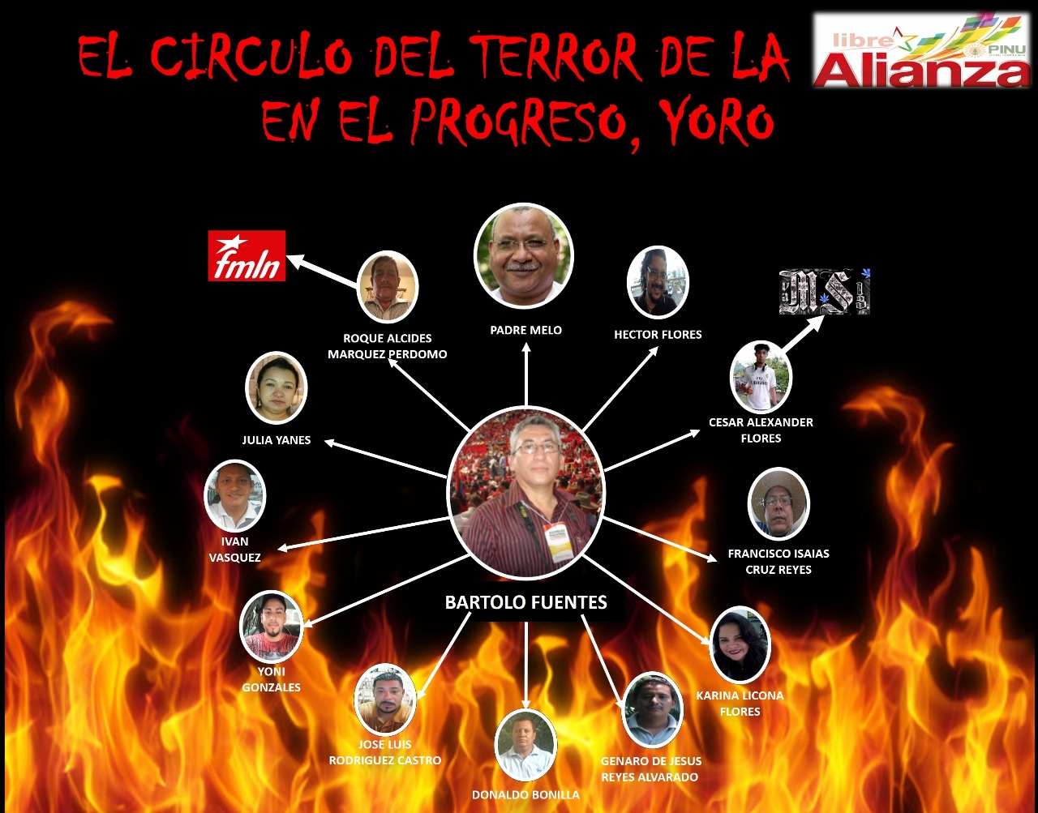

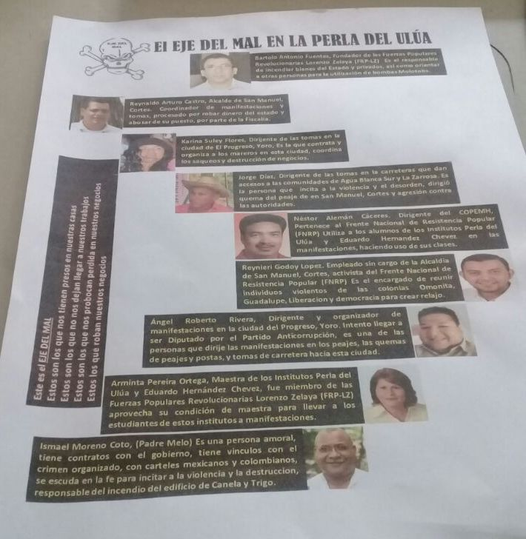

Photographs and Videos from Emergency Faith Delegation to Honduras
January 24-30, 2018

All pictures and videos by Delegate Mark Coplan

Photo Sampler: Emergency Faith Delegation to Honduras
https://www.flickr.com/photos/54922368@N07/sets/72157692762341614

Emergency Faith Delegation to Honduras Sampler Video
(17 min): https://vimeo.com/254782979

(31 min) https://vimeo.com/254999850

Report Authors: Jose Artiga, Alejandro Artiga-Purcell, Jean Stokan, Scott Wright
Report Editors: Jose Artiga, Eileen Purcell, Christine James
Signatories of the report:
- Jose Artiga, Executive Director SHARE Foundation
- Jean Stokan, Sisters of Mercy of the Americas Justice Team
- Rev Deboarh Lee, Executive Director, Interfaith Movement for Human Integrity
- Jenny Atlee, Friendship Office/Honduras Accompaniment Project

https://www.nytimes.com/2017/12/13/world/americas/honduras-election-juan-orlando-hernandez.html; and https://www.theguardian.com/world/2018/jan/02/us-silent-as-honduras-protesters-killed-in-post-election-violence; and http://www.latimes.com/world/la-fg-honduras-election-20171201-story.html

